# UNIT 4 MATRICES

## 4.1 Matrices

### MATRIX

A matrix is a rectangular array of objects, often numbers.

The rectangular array of numbers $\left[\begin{aligned}\begin{matrix}5 & -2 \\ 0 & 4 \\ -6 & 3\end{matrix} \\ \end{aligned}\right]$ is a matrix having 3 rows and 2 columns.

Example (1)

### DIMENSION OF A MATRIX

Matrix having $m$ number of rows and $n$ number of columns has dimension (size) $m×n$ (pronounced as "m by n") and is called an $m×n$ matrix.

The matrix in Example (1) is a $3×2$ matrix since it is composed of 3 rows and 2 columns. When specifying the dimension of a matrix, the number of rows is stated first and the number of columns second.

### ELEMENTS OF A MATRIX

It is common to use an uppercase letter of the alphabet to name a matrix and the corresponding lowercase letter to name an element (entry or member) of the matrix. Subscripts are attached to the lowercase letter to specify its position in the matrix.

The first number in subscript indicates the row in which

the element resides and the second number the column.

The subscript numbers appear adjacent to each other and typically without a comma separating them.

We could name the matrix of Example 1 with the uppercase letter $A$ and write $A=\left[\begin{aligned}\begin{matrix}5 & -2 \\ 0 & 4 \\ -6 & 3\end{matrix} \\ \end{aligned}\right]$.  
  
We specify the element $-2$ in row 1, column 2, with the notation $a_{12}$. The lowercase $a$ is used to indicate that the element is from matrix $A$ and the subscripts indicate we are observing the entry in row 1, column 2. The subscript is not the number 12, but rather the two individual numbers, 1 and 2.

Some other elements of $A$ are

In general, the notation $a_{ij}$ denotes the entry in row $i$ and column $j.$

$a_{11}=5,$ the number in row 1, column 1

$a_{31}=-6,$ the number in row 3, column 1

$a_{22}=4,$ the number in row 2, column 2

In general, an $m×n$ matrix has the form $\left[\begin{aligned}\begin{aligned}\begin{matrix}a_{11} & a_{12}\end{matrix} ⋯ a_{1n} \\ \begin{matrix}a_{21} & a_{22}\end{matrix} ⋯ a_{2n} \\ \begin{matrix}a_{31} & a_{32}\end{matrix} ⋯ a_{3n}\end{aligned} \\ ⋮ \\ \begin{matrix}a_{m1} & a_{m2}\end{matrix} ⋯ a_{mn}\end{aligned}\right]$. For some number $m$, the element $a_{m2}$ is the number in row $m$, column 2.

##### your turn:

In the matrix $B=\left[\begin{aligned}\begin{matrix}0 & -4 & 2 \\ 1 & -1 & 5 \\ -3 & 3 & 8\end{matrix} \\ \end{aligned}\right],$

1. Specify the size of $B$.
2. Find the value of $b_{11}.$
3. Find the value of $b_{13}.$
4. Find the value of $b_{32}.$

ANS: (a) $3×3$, (b) 0, (c) 2, (d) 3

### EQUAL MATRICES

Two matrices $A$ and $B$ are said to be equal, written as $A=B$, if they are the same size and all the corresponding entries are equal.

In matrix notation, for all $i$ and $j$, $A=B$ if $a_{ij}=b_{ij}.$ The notation $a_{ij}$ names the element in row $i$ and column $j$ of matrix $A$. Similarly, the notation $b_{ij}$ names the element in row $i$ and column $j$ of matrix $B$. The notation $a_{ij}=b_{ij}$ indicates that the element in row $i$ and column $j$ of matrix $A$ is the same as the element in row $i$ and column $j$ of matrix $B.$

### SQUARE MATRICES

A matrix is called square if it has the same number of columns as rows.

The $2×2$ matrices $A$ and $B$ are both equal and square.

Example (2)

$A=\left[\begin{matrix}3 & 4 \\ 2 & 1\end{matrix}\right]$ and $B=\left[\begin{matrix}3 & 4 \\ 2 & 1\end{matrix}\right]$

##### MAIN DIAGONAL OF A SQUARE MATRIX

Consider a square matrix, say $A=\left[\begin{matrix}2 & 1 & 0 \\ 3 & 4 & -5 \\ -1 & 6 & 7\end{matrix}\right]$. Imagine a line passing from the top left element to the bottom right element as in the picture.

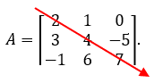

This diagonal set of elements from the top left element to the bottom right is called the main diagonal of the matrix.

##### DIAGONAL AND NON-DIAGONAL ELEMENTS OF A MATRIX

The elements lying on the main diagonal of matrix $A$ are called the diagonal elements of matrix $A$. The elements 2, 4, and 7 are the diagonal elements of matrix $A$. The elements lying off the main diagonal of matrix $A$ are called the non-diagonal or off-diagonal elements of matrix $A$. The elements 1, 0, 3, -5, -1, and 6 are the non-diagonal elements of matrix $A$.

### THE IDENTITY MATRIX

An Identity matrix is a square matrix that has only 1’s on its main diagonal and 0’s everywhere else.

A matrix in which every diagonal element is 1 and every non-diagonal element is 0 is an identity matrix. Identity matrices are typically named with the uppercase letter $I.$ It is not uncommon to write the size of the matrix as a subscript on the $I.$

The square matrix $I=\left[\begin{matrix}1 & 0 & 0 \\ 0 & 1 & 0 \\ 0 & 0 & 1\end{matrix}\right]$ is the $3×3$. We could write $I_{3×3}$ to indicate the $3×3$ identity matrix.

Example (3)

### THE ZERO MATRIX

The zero matrix is a matrix, in which every element is 0.

Zero matrices are commonly named with a 0.

The matrix $0=\left[\begin{matrix}0 & 0 \\ 0 & 0 \\ 0 & 0\end{matrix}\right]$ is a zero matrix.

Example (4)

### THE TRANSPOSE OF A MATRIX

Consider some $m×n$ matrix $A.$ For example, suppose $A$ is the $2×3$ matrix $A=\left[\begin{matrix}2 & 3 & 4 \\ 5 & 6 & 7\end{matrix}\right]$.  
Form a new matrix, call it $A$-transpose and denote it by $A^{T}$, by making

* The first row of $A$ the first column of $A^{T}$,
* The second row of $A$ the second column of $A^{T}$.

Then $A^{T}=\left[\begin{matrix}2 & 5 \\ 3 & 6 \\ 4 & 7\end{matrix}\right]$ is the transpose of $A= \left[\begin{matrix}2 & 3 & 4 \\ 5 & 6 & 7\end{matrix}\right]$.

The rows of a matrix are the columns of its transpose. If the matrix $A$ is size $m×n$,  
then dimension of $A^{T}$ is $n×m$.

### ROW MATRICES AND COLUMN MATRICES

A row matrix is a matrix with only one row and any number of columns.

The matrix $R=\left[\begin{matrix}3 & 4 & 5\end{matrix}\right]$ is a row matrix with 3 columns. It is a $1×3$ matrix.

A column matrix is a matrix with only one column and any number of rows.

The matrix $C=\left[\begin{matrix}6 \\ 7\end{matrix}\right]$ is a column matrix with 2 rows. It is a $2×1$ matrix.

### VECTORS AS MATRICES

When we first described vectors, we expressed them using the bracket notation. For example, we could write a vector as $〈2, 4, 6〉$. We can just as easily describe this vector using a row matrix $\left[\begin{matrix}2 & 4 & 6\end{matrix}\right]$ or column matrix $\left[\begin{matrix}2 \\ 4 \\ 6\end{matrix}\right].$

### 4.1 TRY THESE

1. Specify the dimension of each matrix.
$S=\left[\begin{aligned}\begin{matrix}0 & 2 & 5 \\ -6 & -3 & 2 \\ 1 & 9 & 2\end{matrix} \\ \begin{matrix}8 & -1 & 4\end{matrix}\end{aligned}\right]$

$T=\left[\begin{matrix}5 & 6 & -3 \\ 0 & 0 & -3\end{matrix}\right]$

$Q=\left[\begin{matrix}1 & 0 & -1\end{matrix}\right]$

2. True or False: The transpose of a square matrix is also a square matrix.
3. In the matrix $S=\left[\begin{aligned}\begin{matrix}0 & 2 & 5 \\ -6 & -3 & 2 \\ 1 & 9 & 2\end{matrix} \\ \begin{matrix}8 & -1 & 4\end{matrix}\end{aligned}\right]$
   1. Find the value of $s_{13}.$
   2. Find the value of $s_{23}.$
   3. Find the value of $s_{31}.$
   4. Find the value of $s_{43}.$
4. Construct and name the transpose of $S=\left[\begin{aligned}\begin{matrix}0 & 2 & 5 \\ -6 & -3 & 2 \\ 1 & 9 & 2\end{matrix} \\ \begin{matrix}8 & -1 & 4\end{matrix}\end{aligned}\right]$.
5. Construct $I_{4×4}$.
6. Construct the transpose of $I_{3×3}$.
7. Write the column matrix $\left[\begin{matrix}4 \\ 3 \\ 2\end{matrix}\right]$ using vector bracket notation, < >.
8. Construct a $2×2$ matrix in which the diagonal elements are 5 and 6 and the non-diagonal elements are 0 and 2.

## 4.2 Addition, Subtraction, Scalar Multiplication, and Products of Row and Column Matrices

### Addition and Subtraction of Matrices

Let $A$ and $B$ be $m×n$ matrices. Then the sum, $A+B$, is the new matrix formed by adding corresponding entries together. The difference, $A –B$, is the new matrix formed by subtracting each entry in matrix $B$ from its corresponding entry in matrix $A$.

To add or subtract two or more matrices together, they all must be of the same size. That is, they all must have the same number of rows and the same numbers of columns. To add them together, add the corresponding elements together. To subtract one from the other, subtract corresponding elements from each other.

If the addition and subtraction is defined (if it is possible), perform each operation.

Example (1)

$$A=\left[\begin{matrix}2 & 5 \\ –1 & 4 \\ 6 & 0\end{matrix}\right], B=\left[\begin{matrix}3 & 1 \\ 0 & 4 \\ 2 & 7\end{matrix}\right], C= \left[\begin{matrix}9 & –4 \\ 2 & 6\end{matrix}\right]$$

$A+B=$ $\left[\begin{matrix}2 & 5 \\ –1 & 4 \\ 6 & 0\end{matrix}\right]+\left[\begin{matrix}3 & 1 \\ 0 & 4 \\ 2 & 7\end{matrix}\right]=\left[\begin{matrix}2+3 & 5+1 \\ –1+0 & 4+4 \\ 6+2 & 0+7\end{matrix}\right]=\left[\begin{matrix}5 & 6 \\ –1 & 8 \\ 8 & 7\end{matrix}\right]$

$A –B=$ $=$ $\left[\begin{matrix}2 & 5 \\ –1 & 4 \\ 6 & 0\end{matrix}\right]–\left[\begin{matrix}3 & 1 \\ 0 & 4 \\ 2 & 7\end{matrix}\right]=\left[\begin{matrix}2 –3 & 5 –1 \\ –1 –0 & 4 –4 \\ 6 –2 & 0 –7\end{matrix}\right]=\left[\begin{matrix}–1 & 4 \\ –1 & 0 \\ 4 & –7\end{matrix}\right]$

$A+C$ is not defined as they are different sizes. Matrix $A$ is a $3×2$ matrix whereas matrix $B$ is a $2×2$ matrix.

YOUr TURN: Compute $B –A.$

### Scalar Multiplication

You might recall that a scalar is a physical quantity that is defined by only its magnitude and that some examples are speed, time, distance, density, and temperature. They are represented by real numbers (both positive and negative), and they can be operated on using the regular laws of algebra.

To multiply a matrix by a scalar, multiply every element of the matrix by the scalar.

Symbolically, $k∙\left[\begin{aligned}\begin{matrix}a_{11} & a_{12}\end{matrix} ⋯ a_{1n} \\ \begin{matrix}a_{21} & a_{22} ⋯ a_{2n}\end{matrix} \\ \begin{matrix}⋮ & ⋮ ⋮\end{matrix} \\ \begin{matrix}a_{m1} & a_{m2}\end{matrix} ⋯ a_{mn}\end{aligned}\right]= \left[\begin{aligned}\begin{matrix}{k∙a}_{11} & {k∙a}_{12}\end{matrix} ⋯ {k∙a}_{1n} \\ \begin{matrix}{k∙a}_{21} & {k∙a}_{22} ⋯ {k∙a}_{2n}\end{matrix} \\ \begin{matrix}⋮ & ⋮ ⋮\end{matrix} \\ \begin{matrix}{k∙a}_{m1} & k∙a_{m2}\end{matrix} ⋯ {k∙a}_{mn}\end{aligned}\right]$

$6∙\left[\begin{matrix}4 & 1 & –3 \\ 0 & 3 & 5\end{matrix}\right]= \left[\begin{matrix}6∙4 & 6∙1 & 6∙(–3) \\ 6∙0 & 6∙3 & 6∙5\end{matrix}\right]= \left[\begin{matrix}24 & 6 & –18 \\ 0 & 18 & 30\end{matrix}\right]$

Example (2)

your turn: Multiply $7 ∙\left[\begin{matrix}4 & 2 \\ –1 & 3\end{matrix}\right]$.

### Multiplication with Row and Column Matrices

Suppose we have two matrices, $A$ and $B,$ where $A$ is a $1×n$ matrix and $B$ is an $n×1$ matrix. That is, $A$ has one row and $n$ columns and $B$ has $n$ rows and only 1 column.

$A=\left[\begin{matrix}a_{1} & a_{2}\end{matrix} ⋯ a_{n}\right]$ and $B=\left[{\begin{aligned}\begin{matrix}b_{1} \\ b_{2} \\ ⋮\end{matrix} \\ b\end{aligned}}_{n}\right]$

The product $A∙B$ is the new matrix obtained by multiplying together the corresponding elements of each matrix then adding those sums together.

$$A∙B=\left[\begin{matrix}a_{1} & a_{2}\end{matrix} ⋯ a_{n}\right] ∙\left[{\begin{aligned}\begin{matrix}b_{1} \\ b_{2} \\ ⋮\end{matrix} \\ b\end{aligned}}_{n}\right]$$

$$A∙B=\left[a_{1}∙b_{1}+a_{2}∙b_{2}+⋯+a_{n}∙b_{n}\right]$$

This product is the sum (addition) of the

first entry in $A$ times the first entry in $B$

second entry in $A$ times the second entry in $B$

$⋮$

last entry in $A$ times the last entry in $B$

Suppose $A=\left[\begin{matrix}2 & 4 & 5\end{matrix}\right]$ and $B=\left[\begin{matrix}1 \\ 4 \\ 3\end{matrix}\right]$. Then,

Example (3)

$A∙B=[\begin{matrix}2 & 4 & 5\end{matrix}]∙\left[\begin{matrix}1 \\ 4 \\ 3\end{matrix}\right]$

$A∙B=[2∙1+4∙4+5∙3]$

$A∙B=[2+16+15]$

$A∙B=[33]$

Notice the dimensions of the two matrices. The number of rows of $B,$ is 3 which is equal to the number of columns of $A,$ which is also 3. The product is a $1×1$ matrix whose dimension is the

(number of rows of $A) ×$ (number of columns of $B$).

your turn: Suppose $A=\left[\begin{matrix}3 & 1\end{matrix} \begin{matrix} –2 & 5\end{matrix}\right]$ and $B=\left[\begin{aligned}\begin{matrix}1 \\ –6\end{matrix} \\ 0 \\ 4\end{aligned}\right]$. Show that $A∙B=[17].$

### Motivation for the Process of Multiplication with Row and Column Matrices

This process of multiplication may not seem intuitive; however, we can motivate it with an example. You probably know, or at least believe, that the revenue $R$ realized by selling $n$ number of units of some product for $p$ dollars per unit is given by $R=np$. Revenue equals (the number of units sold) times the (price of each unit).

$$R=n∙p$$

Suppose your business sells three sizes of boxes, small-sized boxes, medium-sized boxes, and large-sized boxes. Small boxes sell for $3 each, medium boxes for $5 each, and large boxes for $7 each. What would your total revenue be if you sold 20 small-sized boxes, 30 medium-sized boxes, and 40 large-sized boxes?

Example (4)

Using $R=n∙p$, your revenue from the sale of the

small boxes is $R=20∙\$3=\$60$

medium boxes is $R=30∙\$5=\$150$

large boxes is $R=40∙\$7=\$280$

The total revenue is the sum of these three products,

$20∙\$3+30∙\$5+$ $40∙\$7=\$60+\$150+\$280=\$490.$

*We can compute the total revenue using two matrices and matrix multiplication.*

Let the first matrix be the row matrix of the number of boxes sold $N$,

$$N=\left[\begin{matrix}20 & 30 & 40\end{matrix}\right]$$

and the second matrix be the column matrix of the price per boxes sold $P$.

$$P=\left[\begin{matrix}\$3 \\ \$5 \\ \$7\end{matrix}\right]$$

The total revenue is the matrix product

$$R=N∙P$$

$$R=\left[\begin{matrix}20 & 30 & 40\end{matrix}\right]∙\left[\begin{matrix}\$3 \\ \$5 \\ \$7\end{matrix}\right]$$

$$=\left[20∙\$3+30∙\$5+40∙\$7\right]$$

$$=\left[\$490\right]$$

##### Important Observation – See this

Notice that the result of a row and column matrix multiplication is a matrix with exactly one entry. That entry is the sum of a collection of products. In Example 4, the result of the row and column matrix multiplication is a matrix with exactly one entry, $490. The $490 is the sum of the products $20∙\$3,$ $30∙\$5$, and $40∙\$7.$ Don’t let the phrase the sum of a collection of products befuddle you. It means it is the addition (the sum) of a collection of multiplications (products). This idea will be helpful in the next section when we discuss multiplication of matrices of larger dimensions.

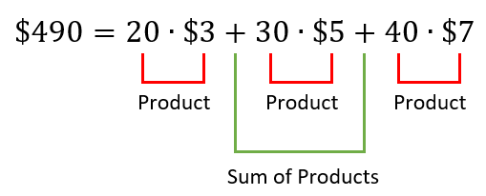

### Dimension Matters

Notice the dimensions of the two matrices $N$ and $P$ from Example 4. The number of rows of $P$ is 3, which is equal to the number columns of $N,$ which is also 3. The product is a $1×1$ matrix whose dimension is (the number of rows of $N) ×$ (the number of columns of $P$).

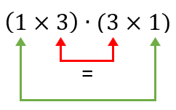

Dimension of the Product

To multiply a row matrix $A$ and column matrix $B$ together, it must be that the

(number of rows of $B)=$ (number of columns of $A)$

Symbolically, if $A$ has $n$ number of columns, $B$ must have $n$ number of rows

Suppose $A=\left[\begin{matrix}2 & 4 & 5\end{matrix}\right]$ and $B=\left[\begin{aligned}\begin{matrix}1 \\ 4 \\ 3\end{matrix} \\ 2\end{aligned}\right]$.

Example (5)

This multiplication will not work, it is not defined. Matrix $B$ has 4 rows, but $A$ has only 3 columns.

$A∙B$ = $\left[\begin{matrix}2 & 4 & 5\end{matrix}\right]$ $∙\left[\begin{aligned}\begin{matrix}1 \\ 4 \\ 3\end{matrix} \\ 2\end{aligned}\right]=\left[2∙1+4∙4+5∙3+Now what?\right]$

### 4.2 Try these

Using these six matrices, perform each operation if it is defined (if it is possible).



$A=\left[\begin{matrix}1 & 2 \\ –1 & 3 \\ 0 & 4\end{matrix}\right] B=\left[\begin{matrix}3 & 2 \\ 1 & 0 \\ –1 & –2\end{matrix}\right]$ $C=\left[\begin{matrix}2 & 1 & 3 \\ 4 & 2 & 1\end{matrix}\right]$ $D=\left[\begin{matrix}4 & 9\end{matrix}\right]$ $E=\left[\begin{matrix}5 \\ 2\end{matrix}\right] F=\left[–2\right]$

$A+B$

$B –A$

$D+E$

$D∙E$

$E∙D$

$–3∙\left[\begin{matrix}–4 & 0 \\ 2 & –1\end{matrix}\right]$

$A+C$

$3∙\left(D∙E\right)$

$\left(D∙E\right)∙F$

$F^{2}$

## 4.3 Matrix Multiplication

### Compatible Matrices

We are going to multiply together two matrices, one of size $m×n$, and one of size $n×p$. The multiplication will be possible, and the product exists because the sizes make them compatible with each other.

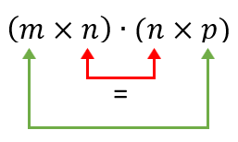

Dimension of the Product

Notice the number of columns of the leftmost matrix is equal to the number of rows of the rightmost matrix.

For the product, $A∙B,$ of two matrices to exist it must be that

(the number of columns of matrix $A$) = (the number of rows of matrix $B$)

Matrices for which this is true are said to be compatible with each other.

### Matrices as Collections of Row and Column Matrices

It is productive to think of a matrix as a collection of individual row matrices and column matrices.  
For example, we can think of the matrix $A=\left[\begin{matrix}3 & 1 \\ –4 & 2 \\ 0 & 5\end{matrix}\right]$ as being composed of

* the three row matrices, $\left[\begin{matrix}3 & 1\end{matrix}\right], \left[\begin{matrix}–4 & 2\end{matrix}\right],$ and $\left[\begin{matrix}0 & 5\end{matrix}\right],$ and
* the two column matrices $\left[\begin{matrix}3 \\ –4 \\ 0\end{matrix}\right]$ and $\left[\begin{matrix}1 \\ 2 \\ 5\end{matrix}\right]$.

(If you need a review of row and column matrices, see Section 4.2)

### Multiplication of Two Matrices

To multiply two compatible matrices $A$ and $B$ together, multiply  
every row matrix of $A$ through every column matrix of $B$.

Suppose the size of matrix $A$ is $3×4$ and the size of matrix $B$ is $4×5$. The matrices are compatible with each other and the size of the product is $3×5$

Some of the entries of the product $A∙B$ are

$a_{11}$: The entry in row 1, column 1, is the result of multiplying the

1st row of matrix $A$ through the 1st column of matrix $B$.

$a_{12}$: The entry in row 1, column 2, is the result of multiplying the

1st row of matrix $A$ through the 2nd column of matrix $B$.

$a_{24}$: The entry in row 2, column 4, is the result of multiplying the

2nd row of matrix $A$ through the 4th column of matrix $B$.

$a_{35}$: The entry in row 3, column $5$, is the result of multiplying the

3rd row of matrix $A$ through the 5th column of matrix $B$.

$a_{33}$: The entry in row 3, column 3, is the result of multiplying the

3rd row of matrix $A$ through the 3rd column of matrix $B$.

Do you see the general rule for producing any particular entry?

To get the entry in row $i$ and column $j$, $a_{ij},$ multiply

the $ith$ row of matrix $A$ through the $jth$ column of matrix $B.$

Compute the product of the matrices $A=\left[\begin{matrix}3 & 1 \\ –4 & 2 \\ 0 & 5\end{matrix}\right]$ and $B=\left[\begin{matrix}3 & 2 \\ 4 & 1\end{matrix}\right]$.

Example (1)

First note that the two matrices are compatible

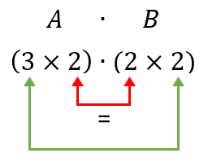

Dimension of the Product is 3 x 2

$A∙B=\left[\begin{matrix}3 & 1 \\ –4 & 2 \\ 0 & 5\end{matrix}\right] ∙\left[\begin{matrix}3 & 2 \\ 4 & 1\end{matrix}\right]$

The product is the $3×2$ matrix of the form $\left[\begin{matrix}a_{11} & a_{12} \\ a_{21} & a_{22} \\ a_{31} & a_{32}\end{matrix}\right]$

Since we are multiplying 3 rows through 2 columns, there will be 6 entries. The six entries of $A∙B$ are

$a_{11}=$ the 1st row of $A$ times the 1st column of $B$

= $\left[\begin{matrix}3 & 1\end{matrix}\right]∙\left[\begin{matrix}3 \\ 4\end{matrix}\right]$ = $\left[3∙3+1∙4\right]=\left[13\right]$

$a_{12}=$ the 1st row of $A$ times the 2nd column of $B$

= $\left[\begin{matrix}3 & 1\end{matrix}\right]∙\left[\begin{matrix}2 \\ 1\end{matrix}\right]$ = $\left[3∙2+1∙1\right]=\left[7\right]$

$a_{21}=$ the 2nd row of $A$ times the 1st column of $B$

= $\left[\begin{matrix}–4 & 2\end{matrix}\right]∙\left[\begin{matrix}3 \\ 4\end{matrix}\right]$ = $\left[–4∙3+2∙4\right]=\left[–4\right]$

$a_{22}=$ the 2nd row of $A$ times the 2nd column of $B$

= $\left[\begin{matrix}–4 & 2\end{matrix}\right]∙\left[\begin{matrix}2 \\ 1\end{matrix}\right]$ = $\left[–4∙2+2∙1\right]=\left[–6\right]$

$a_{31}=$ the 3rd row of $A$ times the 1st column of $B$

= $\left[\begin{matrix}0 & 5\end{matrix}\right]∙\left[\begin{matrix}3 \\ 4\end{matrix}\right]$ = $\left[0∙3+5∙4\right]=\left[20\right]$

$a_{32}=$ the 3rd row of $A$ times the 2nd column of $B$

= $\left[\begin{matrix}0 & 5\end{matrix}\right]∙\left[\begin{matrix}2 \\ 1\end{matrix}\right]$ = $\left[0∙2+5∙1\right]=\left[5\right]$

So, $A∙B=\left[\begin{matrix}13 & 7 \\ –4 & –6 \\ 20 & 5\end{matrix}\right]$

your turn: Show that the product of the matrices $A=\left[\begin{matrix}2 & 3 \\ 4 & 1\end{matrix}\right]$ and $B=\left[\begin{matrix}2 & 3 & 0 \\ 1 & 2 & 4\end{matrix}\right]$ is $\left[\begin{matrix}7 & 12 & 12 \\ 9 & 14 & 4\end{matrix}\right]$.

### Using Technology

You can see that multiplying matrices together involves a lot of arithmetic and can be cumbersome. We can use technology to help us through the process.

Go to www.wolframalpha.com.

To find the product of the two matrices of above Your Turn Example, enter [[2,3], [4,1]] * [[2,3,0], [1,2,4]] in the entry field. WolframAlpha sees a matrix as a collection of row matrices.

These outer square brackets begin and end the actual matrix.

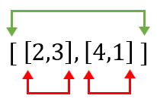

These inner square brackets begin and end each row of the matrix.

Both entries and rows are separated by commas and W|A does not see spaces.

Wolframalpha tells you what it thinks you entered, then tells you its answer $\left[\begin{matrix}7 & 12 & 12 \\ 9 & 14 & 4\end{matrix}\right]$.

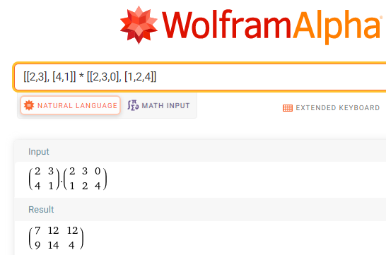

### 4.3 Try these

Perform each multiplication if it is defined. If it is not defined, write "not defined."

$A=\left[\begin{matrix}1 & 2 \\ –1 & 3 \\ 0 & 4\end{matrix}\right] B=\left[\begin{matrix}3 & 2 \\ 1 & 0 \\ –1 & –2\end{matrix}\right]$ $C=\left[\begin{matrix}2 & 1 & 3 \\ 4 & 2 & 1\end{matrix}\right]$ $D=\left[\begin{matrix}–2 & 6 \\ 4 & 1\end{matrix}\right]$ $E=\left[\begin{matrix}5 \\ 2\end{matrix}\right] F=\left[\begin{matrix}2 \\ 1 \\ 5\end{matrix}\right]$

$A∙C$

$C∙A$

1. Compare your answers to question 1 and 2. If you got them right, would you say that matrix multiplication is or is not commutative?

$D∙C$

$C∙F$

$A∙E$

$D^{2}$

$D∙\left[\begin{matrix}1 & 0 \\ 0 & 1\end{matrix}\right]$

$B∙D$

$B∙D∙C$

$D∙B$

## 4.4 Rotation Matrices in 2-Dimensions

### The Rotation Matrix

To this point, we worked with vectors and with matrices. Now, we will put them together to see how to use a matrix multiplication to rotate a vector in the counterclockwise direction through some angle $θ$ in 2-dimensions.

|  |  |
| --- | --- |
| This image shows two vectors on the xy plane: vector v and vector v'. Vector v = [x,y] and vector v' = [x',y'].  Vector v and vector v' are separated by theta degrees. | Diagram of vector v and its rotational  vector v'. Vector v is rotated counterclockwise through an angle. The matrix values of vector v and vector v' have not been changed. |

Our plan is to rotate the vector $v=\left[\begin{matrix}x \\ y\end{matrix}\right]$ counterclockwise through some angle $θ$ to the new position given by the vector $v^{'}=\left[{\begin{matrix}x \\ y^{'}\end{matrix}}^{'}\right]$. To do so, we use the rotation matrix, a matrix that rotates points in the $xy$-plane counterclockwise through an angle $θ$ relative to the $x$-axis.

$$\left[\begin{matrix}cosθ & -sinθ \\ sinθ & cosθ\end{matrix}\right]$$

### The Rotation Process

To get the coordinates of the new vector $\left[{\begin{matrix}x \\ y^{'}\end{matrix}}^{'}\right],$ perform the matrix multiplication

$$\left[{\begin{matrix}x \\ y^{'}\end{matrix}}^{'}\right]=\left[\begin{matrix}cosθ & –sinθ \\ sinθ & cosθ\end{matrix}\right]\left[\begin{matrix}x \\ y\end{matrix}\right]$$

Find the vector $\left[{\begin{matrix}x \\ y^{'}\end{matrix}}^{'}\right]$ that results when the vector $\left[\begin{matrix}x \\ y\end{matrix}\right]=\left[\begin{matrix}1 \\ –1\end{matrix}\right]$ is rotated 90° counterclockwise.

Example (1)

Using the rotation formula $\left[{\begin{matrix}x \\ y^{'}\end{matrix}}^{'}\right]=\left[\begin{matrix}cosθ & -sinθ \\ sinθ & cosθ\end{matrix}\right]\left[\begin{matrix}x \\ y\end{matrix}\right]$ with $\left[\begin{matrix}x \\ y\end{matrix}\right]=\left[\begin{matrix}1 \\ –1\end{matrix}\right]$

and $θ=90°,$ we get

$\left[{\begin{matrix}x \\ y^{'}\end{matrix}}^{'}\right]=\left[\begin{matrix}cosθ & –sinθ \\ sinθ & cosθ\end{matrix}\right]\left[\begin{matrix}x \\ y\end{matrix}\right]=\left[\begin{matrix}cos90° & –sin90° \\ sin90° & cos90°\end{matrix}\right]\left[\begin{matrix}1 \\ –1\end{matrix}\right]$

$\left[{\begin{matrix}x \\ y^{'}\end{matrix}}^{'}\right]=\left[\begin{matrix}0 & –1 \\ 1 & 0\end{matrix}\right]\left[\begin{matrix}1 \\ -1\end{matrix}\right]=\left[\begin{matrix}0∙1+\left(–1\right)∙\left(–1\right) \\ 1∙1+0∙\left(–1\right)\end{matrix}\right]$

$\left[{\begin{matrix}x \\ y^{'}\end{matrix}}^{'}\right]=\left[\begin{matrix}1 \\ 1\end{matrix}\right]$

When rotated counterclockwise 90°, the vector $\left[\begin{matrix}1 \\ –1\end{matrix}\right]$ becomes .

|  |  |
| --- | --- |
| This image shows a vector v = [1,negative 1] in the xy plane. | This images shows that vector v = [1,negative 1] has been rotated counterclockwise through 90 degrees into v' = [1,1]. |

Find the vector $\left[{\begin{matrix}x \\ y^{'}\end{matrix}}^{'}\right]$ that results when the vector $\left[\begin{matrix}x \\ y\end{matrix}\right]=\left[\begin{matrix}2 \\ 6\end{matrix}\right]$ is rotated 60° counterclockwise.

Example (2)

Using the rotation formula $\left[{\begin{matrix}x \\ y^{'}\end{matrix}}^{'}\right]=\left[\begin{matrix}cosθ & -sinθ \\ sinθ & cosθ\end{matrix}\right]\left[\begin{matrix}x \\ y\end{matrix}\right]$ with $\left[\begin{matrix}x \\ y\end{matrix}\right]=\left[\begin{matrix}2 \\ 6\end{matrix}\right]$ and $θ=60°,$ we get

$\left[{\begin{matrix}x \\ y^{'}\end{matrix}}^{'}\right]=\left[\begin{matrix}cosθ & –sinθ \\ sinθ & cosθ\end{matrix}\right]\left[\begin{matrix}x \\ y\end{matrix}\right]=\left[\begin{matrix}cos60° & –sin60° \\ sin60° & cos60°\end{matrix}\right]\left[\begin{matrix}2 \\ 6\end{matrix}\right]$

$\left[{\begin{matrix}x \\ y^{'}\end{matrix}}^{'}\right]=\left[\begin{matrix}1/2 & –\sqrt{3}/2 \\ \sqrt{3}/2 & 1/2\end{matrix}\right]\left[\begin{matrix}2 \\ 6\end{matrix}\right]=\left[\begin{matrix}1/2∙2+\left(–\sqrt{3}/2\right)∙6 \\ \sqrt{3}/2∙2+1/2∙6\end{matrix}\right]$

$\left[{\begin{matrix}x \\ y^{'}\end{matrix}}^{'}\right]=\left[\begin{matrix}1–3\sqrt{3} \\ 3+\sqrt{3}\end{matrix}\right]$

When rotated counterclockwise 60°, the vector $\left[\begin{matrix}2 \\ 6\end{matrix}\right]$ becomes .

|  |  |
| --- | --- |
| This image shows  vector v = [2,6]. | This image shows the vector v = [2,6] being rotated counterclockwise 60 degrees to become v' = [1 -  (3  multiplied by square root of 3), 3 + square root of 3]. |

### Using Technology

We can use technology to help us find the rotation. WolframAlpha evaluates the trig functions for us.

Go to www.wolframalpha.com.

We can check the above problem from Example 2 by using WolframAlpha. Find the vector $\left[{\begin{matrix}x \\ y^{'}\end{matrix}}^{'}\right]$ that results when the vector $\left[\begin{matrix}x \\ y\end{matrix}\right]=\left[\begin{matrix}2 \\ 6\end{matrix}\right]$ is rotated 60° counterclockwise. To find rotation of the vector enter evaluate [[cos(60), –sin(60)], [sin(60), cos(60)]] * [2,6] into the entry field.

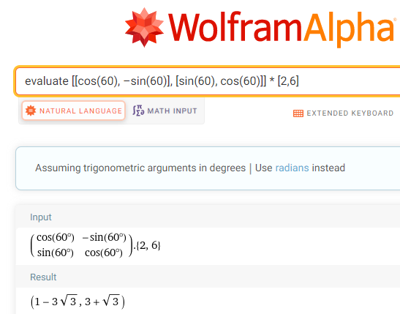

When rotated counterclockwise 60°, the vector $\left[\begin{matrix}2 \\ 6\end{matrix}\right]$ becomes $\left[\begin{matrix}1–3\sqrt{3} \\ 3+\sqrt{3}\end{matrix}\right]$.

### 4.4 Try these

1. Find the vector $\left[{\begin{matrix}x \\ y^{'}\end{matrix}}^{'}\right]$ that results when $\left[\begin{matrix}x \\ y\end{matrix}\right]=\left[\begin{matrix}1 \\ 1\end{matrix}\right]$ is rotated 90° counterclockwise.
2. Find the vector $\left[{\begin{matrix}x \\ y^{'}\end{matrix}}^{'}\right]$ that results when $\left[\begin{matrix}x \\ y\end{matrix}\right]=\left[\begin{matrix}1 \\ 1\end{matrix}\right]$ is rotated 180° counterclockwise.
3. Find the vector $\left[{\begin{matrix}x \\ y^{'}\end{matrix}}^{'}\right]$ that results when $\left[\begin{matrix}x \\ y\end{matrix}\right]=\left[\begin{matrix}1 \\ 1\end{matrix}\right]$ is rotated 270° counterclockwise.
4. Find the vector $\left[{\begin{matrix}x \\ y^{'}\end{matrix}}^{'}\right]$ that results when $\left[\begin{matrix}x \\ y\end{matrix}\right]=\left[\begin{matrix}0 \\ 1\end{matrix}\right]$ is rotated 90° counterclockwise.
5. Find the vector $\left[{\begin{matrix}x \\ y^{'}\end{matrix}}^{'}\right]$ that results when $\left[\begin{matrix}x \\ y\end{matrix}\right]=\left[\begin{matrix}1 \\ 1\end{matrix}\right]$ is rotated 45° counterclockwise.
6. Find the vector $\left[{\begin{matrix}x \\ y^{'}\end{matrix}}^{'}\right]$ that results when $\left[\begin{matrix}x \\ y\end{matrix}\right]=\left[\begin{matrix}–1 \\ 1\end{matrix}\right]$ is rotated 45° counterclockwise.
7. Find the vector $\left[{\begin{matrix}x \\ y^{'}\end{matrix}}^{'}\right]$ that results when $\left[\begin{matrix}x \\ y\end{matrix}\right]=\left[\begin{matrix}–2.20205 \\ 4.48898\end{matrix}\right]$ is rotated $-63$ ° counterclockwise.
8. Find the vector $\left[{\begin{matrix}x \\ y^{'}\end{matrix}}^{'}\right]$ that results when $\left[\begin{matrix}x \\ y\end{matrix}\right]=\left[\begin{matrix}–3 \\ –3\end{matrix}\right]$ is rotated $-90$ ° counterclockwise.
9. Approximate, to five decimal places, the coordinates of the vector $\left[\begin{matrix}x \\ y\end{matrix}\right]=\left[\begin{matrix}–1 \\ 1\end{matrix}\right]$ when it is rotated counterclockwise 30°.

## 4.5 Finding the Angle of Rotation Between Two Rotated Vectors in 2-Dimensions

### Given the Rotated Vector, Find the Angle of Rotation

Suppose we did not know the angle $θ$ of rotation. We can get it by working backwards and solving a system of equations. The rotation formula

$$\left[{\begin{matrix}x \\ y^{'}\end{matrix}}^{'}\right]=\left[\begin{matrix}cosθ & –sinθ \\ sinθ & cosθ\end{matrix}\right]\left[\begin{matrix}x \\ y\end{matrix}\right]$$

produces the system of equations

$$\left\{\begin{matrix}x^{'}=x∙cosθ+y∙\left(-sinθ\right) \\ y^{'}=x∙sinθ+y∙cosθ\end{matrix}\right.$$

In Example 1 of Chapter 4.4, we found that when the vector $\left[\begin{matrix}x \\ y\end{matrix}\right]=\left[\begin{matrix}1 \\ -1\end{matrix}\right]$ was rotated counterclockwise by 90°, it became the vector $\left[{\begin{matrix}x \\ y^{'}\end{matrix}}^{'}\right]=\left[\begin{matrix}1 \\ 1\end{matrix}\right]$. We got this rotated vector by applying the rotation formula $\left[\begin{matrix}cosθ & -sinθ \\ sinθ & cosθ\end{matrix}\right].$

Example (1)

$$\left[{\begin{matrix}x \\ y^{'}\end{matrix}}^{'}\right]=\left[\begin{matrix}cosθ & -sinθ \\ sinθ & cosθ\end{matrix}\right]\left[\begin{matrix}x \\ y\end{matrix}\right]$$

$$\left[\begin{matrix}1 \\ 1\end{matrix}\right]=\left[\begin{matrix}cosθ & -sinθ \\ sinθ & cosθ\end{matrix}\right]\left[\begin{matrix}1 \\ -1\end{matrix}\right]$$

$$\left[\begin{matrix}1 \\ 1\end{matrix}\right] =\left[\begin{matrix}1∙cosθ+(-1)∙\left(-sinθ\right) \\ 1∙sinθ+(-1)∙cosθ\end{matrix}\right]$$

Since two vectors are equal only if their corresponding components are equal, we have the system of two equations

$$\left\{\begin{matrix}1=1∙cosθ+(-1)∙\left(-sinθ\right) \\ 1=1∙sinθ+(-1)∙cosθ\end{matrix}\right.$$

### Using Technology

We can use WolframAlpha to help us solve above system for the angle of rotation, $θ.$

Go to www.wolframalpha.com.

Since we want to rotate only one time around the coordinate system, we want to instruct W|A to give us solutions only where the angle $θ$ is between 0 and 2 $π$.

Using the English letter x in place of the Greek letter $θ,$ enter

Solve 1 = 1*cos(x) + (-1)*(-sin(x)), 1 = 1*sin(x) + (-1)*cos(x), 0 <= x <= 2*pi in the entry field.

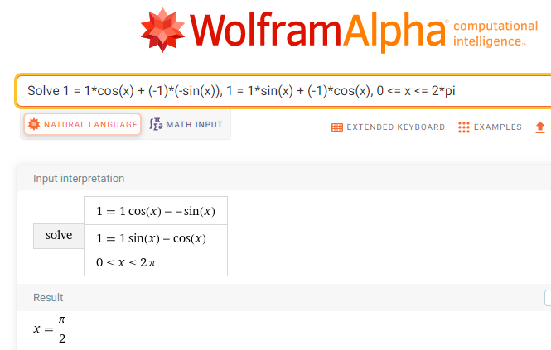

W|A shows the angle of rotation is $θ=\frac{π}{2}$, which is 90°. We conclude that the angle of rotation is 90°.

In Example 2 of Chapter 4.4, we found that when the vector $\left[\begin{matrix}x \\ y\end{matrix}\right]=\left[\begin{matrix}2 \\ 6\end{matrix}\right]$ was rotated counterclockwise by 60°, it became the vector $\left[{\begin{matrix}x \\ y^{'}\end{matrix}}^{'}\right]=\left[\begin{matrix}1-3\sqrt{3} \\ 3+\sqrt{3}\end{matrix}\right]$. We got this rotated vector by applying the rotation formula $\left[\begin{matrix}cosθ & -sinθ \\ sinθ & cosθ\end{matrix}\right].$

Example (2)

$$\left[{\begin{matrix}x \\ y^{'}\end{matrix}}^{'}\right]=\left[\begin{matrix}cosθ & -sinθ \\ sinθ & cosθ\end{matrix}\right]\left[\begin{matrix}x \\ y\end{matrix}\right] \\ \left[\begin{matrix}1-3\sqrt{3} \\ 3+\sqrt{3}\end{matrix}\right]=\left[\begin{matrix}cosθ & -sinθ \\ sinθ & cosθ\end{matrix}\right]\left[\begin{matrix}2 \\ 6\end{matrix}\right] \\ \left[\begin{matrix}1-3\sqrt{3} \\ 3+\sqrt{3}\end{matrix}\right] =\left[\begin{matrix}2∙cosθ+6∙\left(-sinθ\right) \\ 2∙sinθ+6∙cosθ\end{matrix}\right]$$

Since two vectors are equal only if their corresponding components are equal, we have the system of two equations

$$\left\{\begin{matrix}1-3\sqrt{3}=2∙cosθ+6∙\left(-sinθ\right) \\ 3+\sqrt{3}=2∙sinθ+6∙cosθ\end{matrix}\right.$$

We will use WolframAlpha to help us solve this system for the angle of rotation, $θ.$

Using the English letter x in place of the Greek letter $θ,$ enter

Solve 1 – 3sqrt(3) = 2*cos(x) + 6*(–sin(x)), 3 + sqrt(3) = 2*sin(x) + 6*cos(x), 0 <= x <= 2*pi

in the entry field. Separate the two equations with a comma.

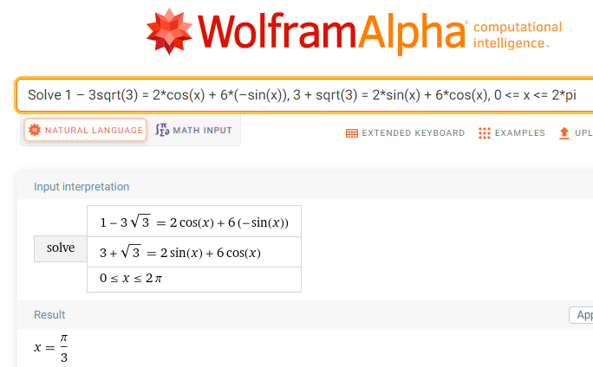

W|A shows the angle of rotation is $θ=\frac{π}{3}$, which is 60°. We conclude that the angle of rotation is 60°.

### 4.5 Try these

1. Find the angle $θ$ through which the vector $\left[\begin{matrix}3 \\ 3\end{matrix}\right]$ is rotated to become $\left[\begin{matrix}0 \\ 3\sqrt{2}\end{matrix}\right]$.
2. Find the angle $θ$ through which the vector $\left[\begin{matrix}2 \\ -2\end{matrix}\right]$ is rotated to become .

1. Find the angle $θ$ through which the vector $\left[\begin{matrix}2 \\ 0\end{matrix}\right]$ is rotated to become .
2. Find the angle $θ$ through which the vector $\left[\begin{matrix}-2 \\ -2\end{matrix}\right]$ is rotated to become $\left[\begin{matrix}-1+\sqrt{3} \\ -1-\sqrt{3}\end{matrix}\right]$.
3. Find the angle $θ$ through which the vector $\left[\begin{matrix}1 \\ 1\end{matrix}\right]$ is rotated to become $\left[\begin{matrix}\sqrt{2} \\ 0\end{matrix}\right]$.

## 4.6 Rotation Matrices in 3-Dimensions

### The Three Basic Rotations

A basic rotation of a vector in 3-dimensions is a rotation around one of the coordinate axes. We can rotate a vector counterclockwise through an angle $θ$ around the $x$–axis, the $y$–axis, or the $z$–axis.

To get a counterclockwise view, imagine looking at an axis straight on toward the origin.

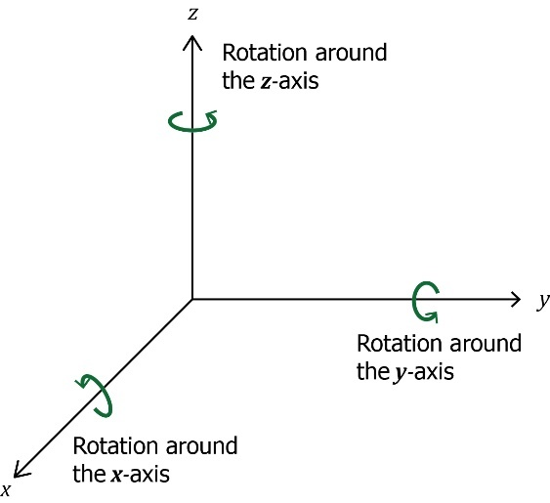

Our plan is to rotate the vector $\left[\begin{matrix}x \\ y \\ z\end{matrix}\right]$ counterclockwise around one of the axes through some angle $θ$ to the new position given by the vector $\left[{\begin{matrix}x \\ y' \\ z'\end{matrix}}^{'}\right]$. To do so, we will use one of the three rotation matrices.

### The Rotation Matrices

The rotation matrices for $x$, $y$, and $z$ axes are, respectively,

$$\left[\begin{matrix}1 & 0 & 0 \\ 0 & cosθ & -sinθ \\ 0 & sinθ & cosθ\end{matrix}\right] \left[\begin{matrix}cosθ & 0 & sinθ \\ 0 & 1 & 0 \\ -sinθ & 0 & cosθ\end{matrix}\right] \left[\begin{matrix}cosθ & -sinθ & 0 \\ sinθ & cosθ & 0 \\ 0 & 0 & 1\end{matrix}\right]$$

### The Rotation Process

To rotate the vector $\left[\begin{matrix}x \\ y \\ z\end{matrix}\right]$ counterclockwise through an angle $θ$ around the $x$–axis to a new position $\left[{\begin{matrix}x \\ y' \\ z'\end{matrix}}^{'}\right],$ perform the matrix multiplication,

##### –axis

To rotate the vector $\left[\begin{matrix}x \\ y \\ z\end{matrix}\right]$ counterclockwise through an angle $θ$ around the $y$–axis to a new position $\left[{\begin{matrix}x \\ y' \\ z'\end{matrix}}^{'}\right],$ perform the matrix multiplication,

##### –axis

To rotate the vector $\left[\begin{matrix}x \\ y \\ z\end{matrix}\right]$ counterclockwise through an angle $θ$ around the $z$–axis to a new position $\left[{\begin{matrix}x \\ y' \\ z'\end{matrix}}^{'}\right],$ perform the matrix multiplication,

##### $z$–axis

$$\left[{\begin{matrix}x \\ y' \\ z'\end{matrix}}^{'}\right]=\left[\begin{matrix}cosθ & -sinθ & 0 \\ sinθ & cosθ & 0 \\ 0 & 0 & 1\end{matrix}\right]∙\left[\begin{matrix}x \\ y \\ z\end{matrix}\right]$$

Find the vector $\left[{\begin{matrix}x \\ y' \\ z'\end{matrix}}^{'}\right]$ that results when the vector $\left[\begin{matrix}x \\ y \\ z\end{matrix}\right]=\left[\begin{matrix}1 \\ 2 \\ 3\end{matrix}\right]$ is rotated 90° counterclockwise around $x$–axis.

Example (1)

Using the rotation formula $\left[{\begin{matrix}x \\ y' \\ z'\end{matrix}}^{'}\right]=\left[\begin{matrix}1 & 0 & 0 \\ 0 & cosθ & -sinθ \\ 0 & sinθ & cosθ\end{matrix}\right]∙\left[\begin{matrix}x \\ y \\ z\end{matrix}\right]$ with $\left[\begin{matrix}x \\ y \\ z\end{matrix}\right]=\left[\begin{matrix}1 \\ 2 \\ 3\end{matrix}\right]$ and $θ=90°,$ we get

$\left[{\begin{matrix}x \\ y' \\ z'\end{matrix}}^{'}\right]=\left[\begin{matrix}1 & 0 & 0 \\ 0 & cosθ & -sinθ \\ 0 & sinθ & cosθ\end{matrix}\right]∙\left[\begin{matrix}x \\ y \\ z\end{matrix}\right] =\left[\begin{matrix}1 & 0 & 0 \\ 0 & cos90° & -sin90° \\ 0 & sin90° & cos90°\end{matrix}\right]∙\left[\begin{matrix}1 \\ 2 \\ 3\end{matrix}\right]$

$\left[{\begin{matrix}x \\ y' \\ z'\end{matrix}}^{'}\right]=\left[\begin{matrix}1 & 0 & 0 \\ 0 & 0 & -1 \\ 0 & 1 & 0\end{matrix}\right]∙\left[\begin{matrix}1 \\ 2 \\ 3\end{matrix}\right]=\left[\begin{matrix}1∙1+0∙2+0∙3 \\ 0∙1+0∙2+(-1)∙3 \\ 0∙1+1∙2+0∙3\end{matrix}\right]$

$\left[{\begin{matrix}x \\ y' \\ z'\end{matrix}}^{'}\right]=\left[\begin{matrix}1 \\ -3 \\ 2\end{matrix}\right]$

When rotated counterclockwise 90° around the $x$–axis, the vector $\left[\begin{matrix}1 \\ 2 \\ 3\end{matrix}\right]$ becomes $\left[\begin{matrix}1 \\ -3 \\ 2\end{matrix}\right]$.

### Using Technology

We can use technology to help us find the rotation. WolframAlpha evaluates the trig functions for us.

Go to www.wolframalpha.com.

In Example 1, we rotated the vector $\left[\begin{matrix}1 \\ 2 \\ 3\end{matrix}\right]$ 90° around the $x$–axis to get $\left[\begin{matrix}1 \\ -3 \\ 2\end{matrix}\right].$

Example (2)

Now we will use WolframAlpha to rotate vector $\left[\begin{matrix}1 \\ 2 \\ 3\end{matrix}\right]$ 90° around the $y$–axis. We use the $y$–axis rotation matrix $\left[\begin{matrix}cosθ & 0 & sinθ \\ 0 & 1 & 0 \\ -sinθ & 0 & cosθ\end{matrix}\right]$.

To perform the rotation, enter Evaluate [[cos(90),0,sin(90)], [0,1,0], [–sin(90),0,cos(90)]] * [1,2,3] into the entry field.

Both entries and rows are separated by commas as W|A does not see spaces.

Wolframalpha tells you what it thinks you entered, then tells you its answer.

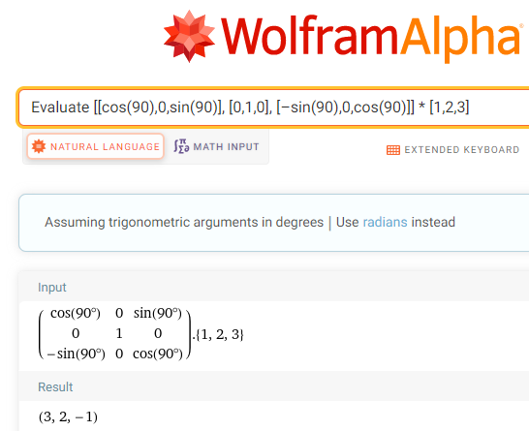

When rotated counterclockwise 90° around the $y$–axis, the vector $\left[\begin{matrix}1 \\ 2 \\ 3\end{matrix}\right]$ becomes $\left[\begin{matrix}3 \\ 2 \\ -1\end{matrix}\right]$.

Find the vector $\left[{\begin{matrix}x \\ y' \\ z'\end{matrix}}^{'}\right]$ that results when the vector $\left[\begin{matrix}x \\ y \\ z\end{matrix}\right]=\left[\begin{matrix}1 \\ 2 \\ 3\end{matrix}\right]$ is rotated 45° counterclockwise around the $z$–axis.

Example (3)

Since we are rotating the vector around the $z$–axis, we use the $z$–axis rotation

matrix $\left[\begin{matrix}cosθ & -sinθ & 0 \\ sinθ & cosθ & 0 \\ 0 & 0 & 1\end{matrix}\right]$.

Using WolframAlpha with $\left[\begin{matrix}x \\ y \\ z\end{matrix}\right]=\left[\begin{matrix}1 \\ 2 \\ 3\end{matrix}\right]$ and $θ=45°,$ we get

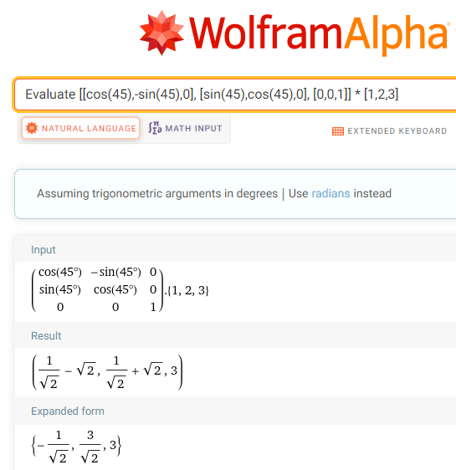

When rotated counterclockwise 45° around the $z$–axis, the vector $\left[\begin{matrix}1 \\ 2 \\ 3\end{matrix}\right]$ becomes $\left[\begin{matrix}-1/\sqrt{2} \\ 3/\sqrt{2} \\ 3\end{matrix}\right]$.

### 

### 4.6 Try these

Find the vector $\left[{\begin{matrix}x \\ y' \\ z'\end{matrix}}^{'}\right]$ that results when the given vector $\left[\begin{matrix}x \\ y \\ z\end{matrix}\right]$ is rotated the given angle $θ$ counterclockwise around the given axis.

1. $\left[\begin{matrix}x \\ y \\ z\end{matrix}\right] =\left[\begin{matrix}1 \\ 1 \\ 1\end{matrix}\right]$ through 90° around the $x$–axis.
2. $\left[\begin{matrix}x \\ y \\ z\end{matrix}\right] =\left[\begin{matrix}1 \\ 0 \\ 1\end{matrix}\right]$ through 45° around the $z$–axis.
3. $\left[\begin{matrix}x \\ y \\ z\end{matrix}\right] =\left[\begin{matrix}3 \\ 4 \\ 5\end{matrix}\right]$ through 30° around the $y$–axis.